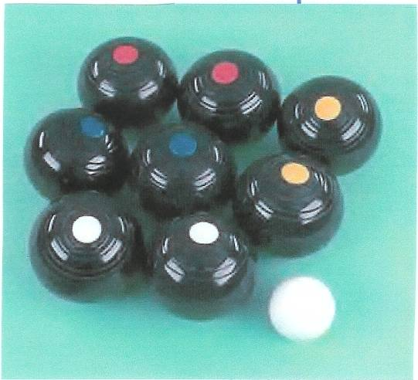 HIGHWOODS CARPET BOWLS CLUB

Notes on Etiquette/Equipment etc

This note has been produced to further your enjoyment of Carpet Bowls and to help preserve the Club’s substantial investment.
Carpet Bowls is known as one of the only indoor sports, where individuals do not have to spend their own money on equipment in order to be able to enjoy their Sport. We are extremely fortunate in not having to individually buy Carpets, Bowls, Boxes, Centre Blocks, End Blocks, Jacks or Scoreboards.
All of these are provided for by YOUR CLUB.
Please help to protect your Club’s investment (Items are expensive to replace) by:
- Not walking on Carpets at any time.
- Only wearing flat shoes on any club or match night.
- Treating equipment with necessary care.

Please show respect to others and do not walk past the end of any carpet whilst a game is in progress. Please also remember that we endeavour to always change ends by walking in a clockwise direction.

Please give all speakers your respect with peace and quiet so that:
- They will not have to repeat themselves.
- Remember by doing so that you will be acquainted with all news and information about your club.
(There will be plenty of time to chat especially at the evening break)

It is important for the Club that everybody assists in their own way by helping to prepare the Hall for play and putting mats & equipment away when we finish.
We have access to the Hall from 7-20 p.m. on a Thursday Club Night.
We start at 7-30 p.m. and finish at 10-15 p.m. with a break in the middle at approx. 9-00 p.m.

We know where the four carpets have to be placed and where the equipment is required.
Please help to get something out. We realise that not everybody can lift Carpets, but Woods, Blocks, Middles, Measures, Jacks, Scoreboards and ‘Tea Strainers’ all have to be put out.
Anybody can additionally volunteer to ‘Hoover’ a carpet, this helps to protect & prolong the life of our equipment.

If you are leaving after the break or not planning to play, please make sure that you let the Captain/Vice Captain know of your intentions and at the break assist with any carpets or equipment that is not needed when we start again.

Please be helpful at all times, use Common Sense and respect the needs of others. In this way we will all enjoy our carpet bowls that little bit more.

Thank You

